Part 1

Noisy Image (Noise Level = 10)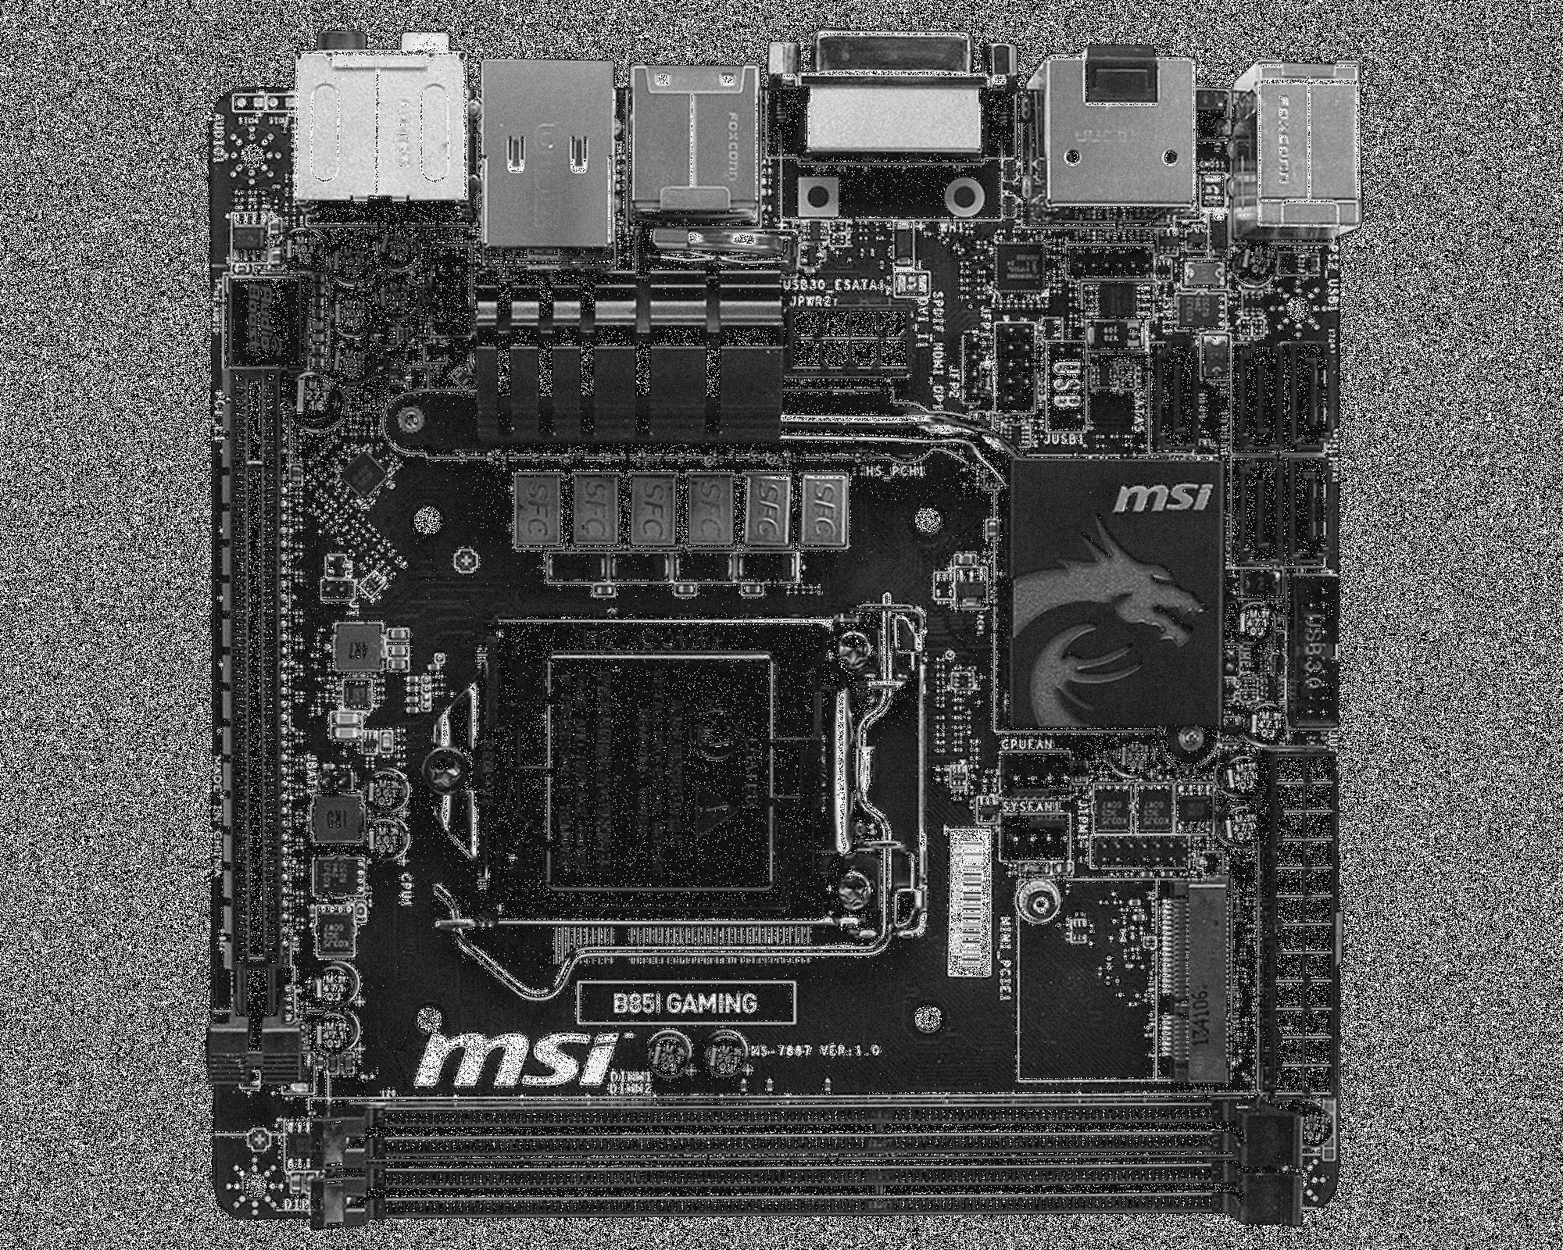

Smoothed Image (Sigma = 5)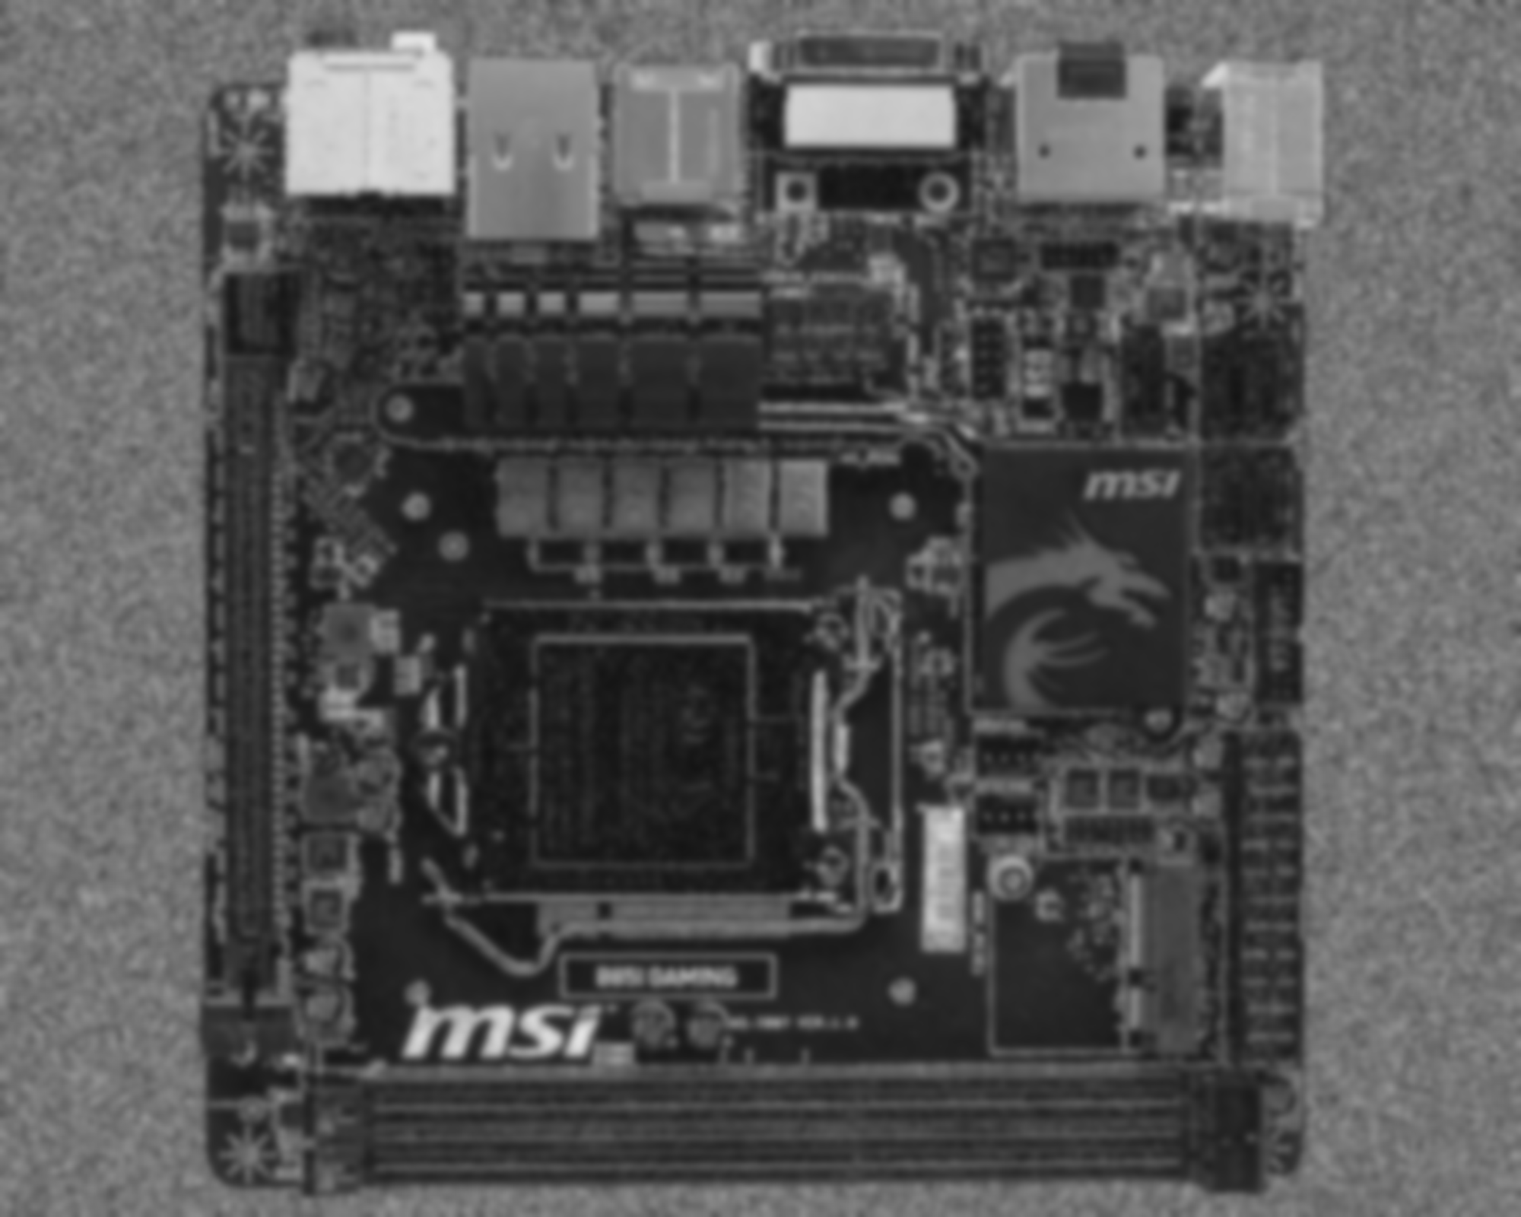

matchTemplate() Output

Normalized between Intensities of 0 and 255

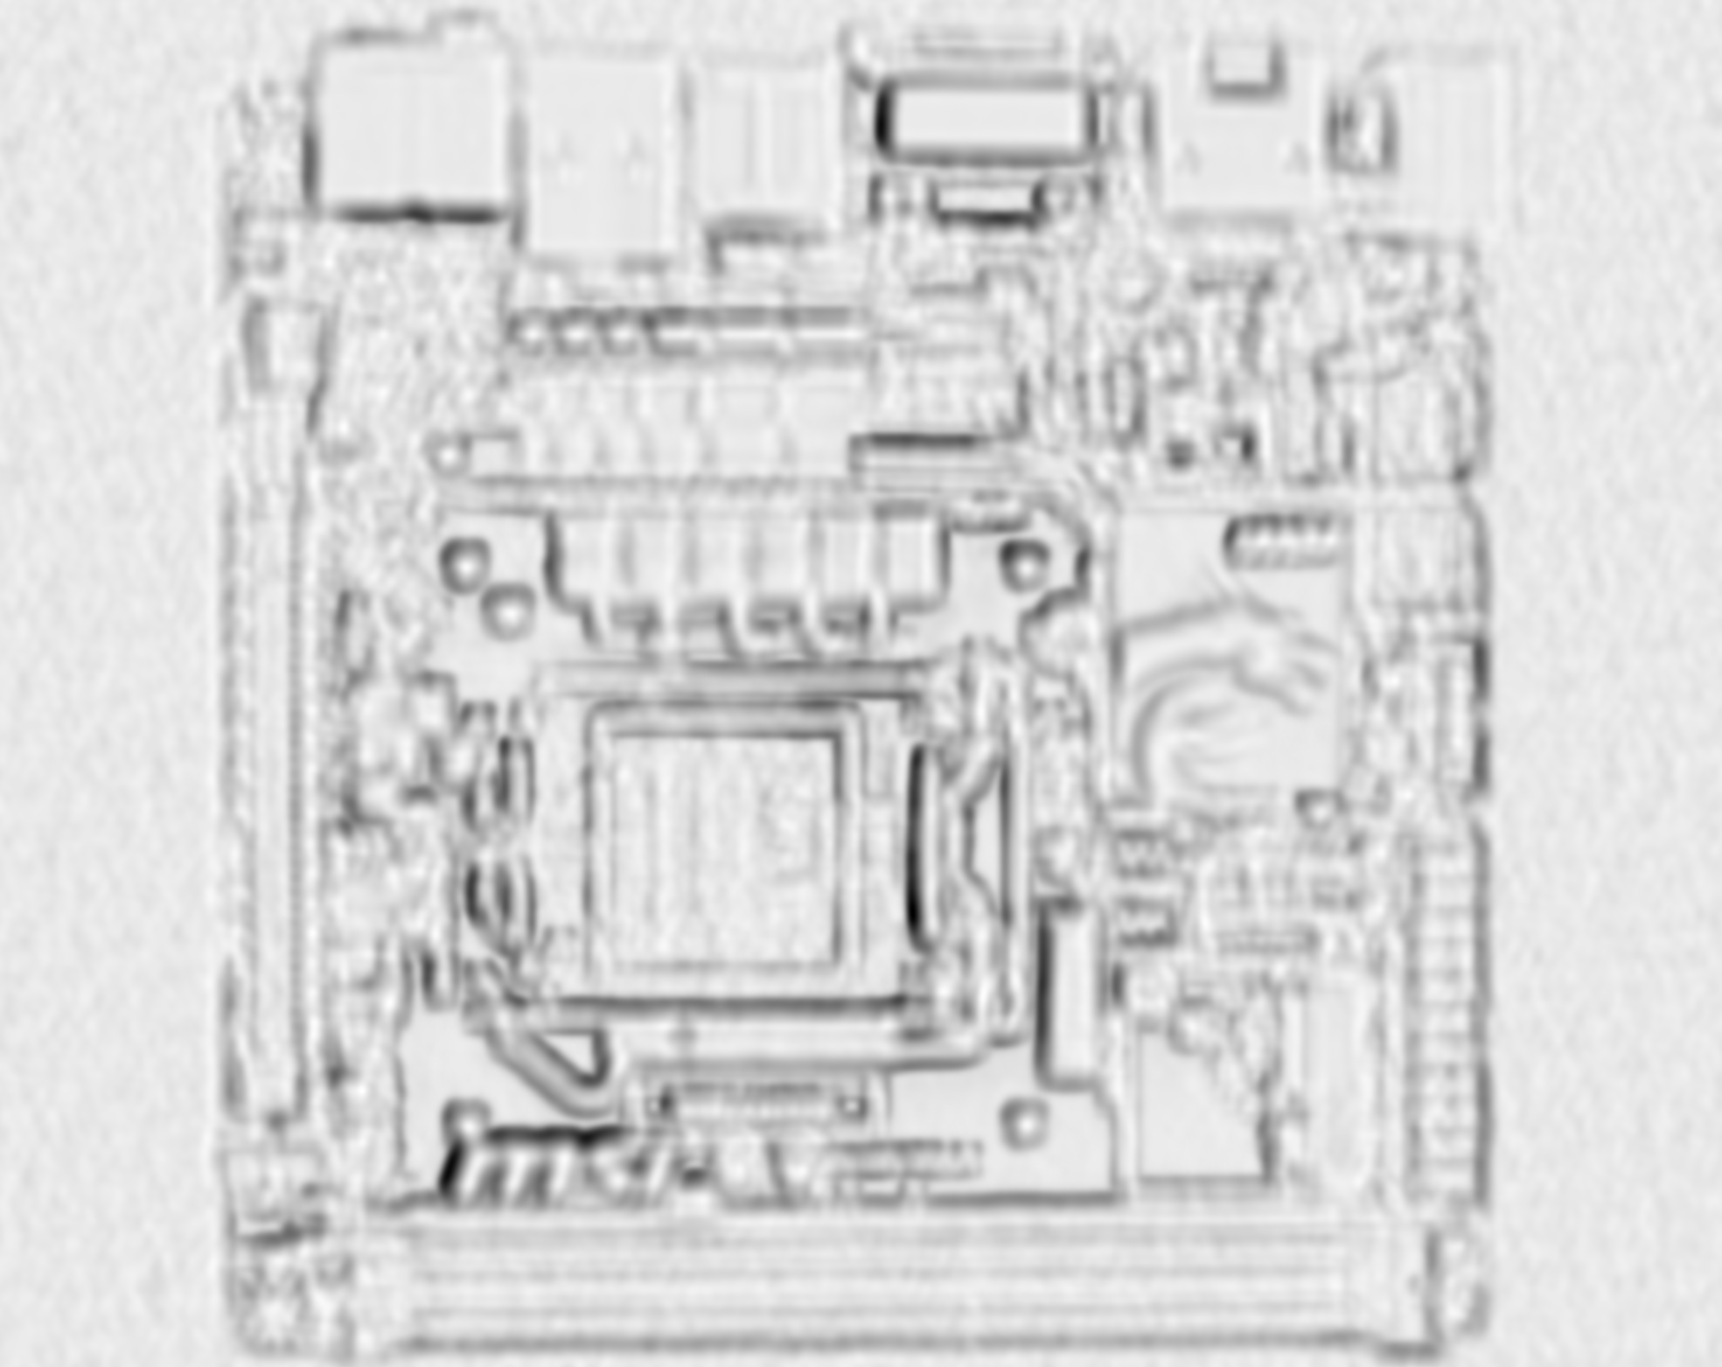

Histogram Equalized

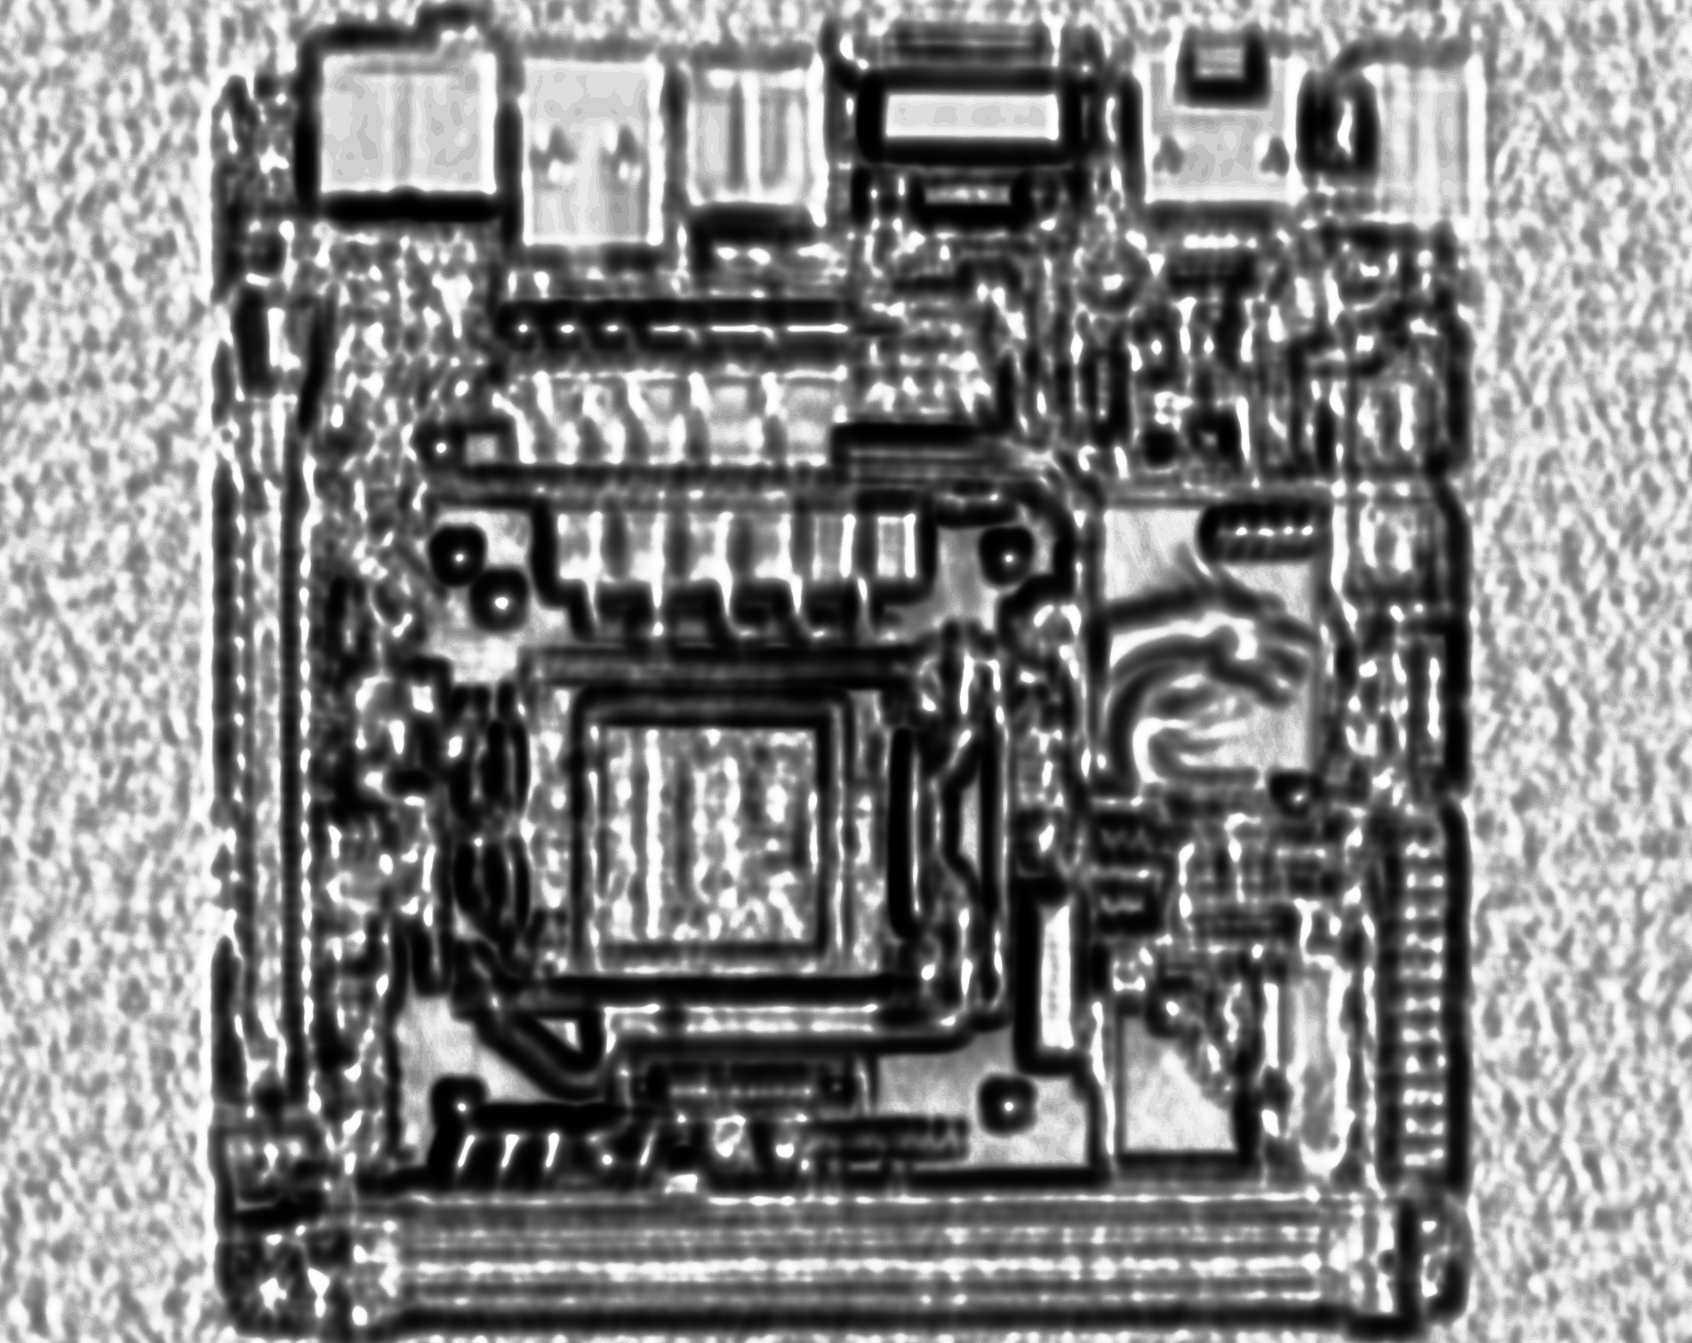

Piecewise-Linear Transformed

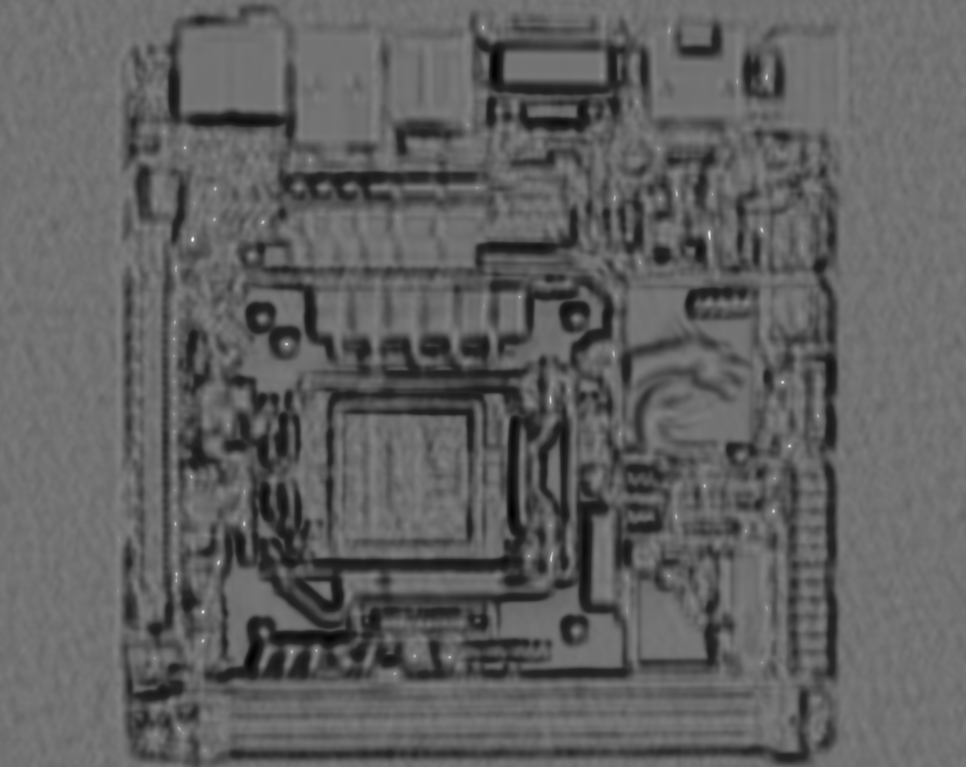

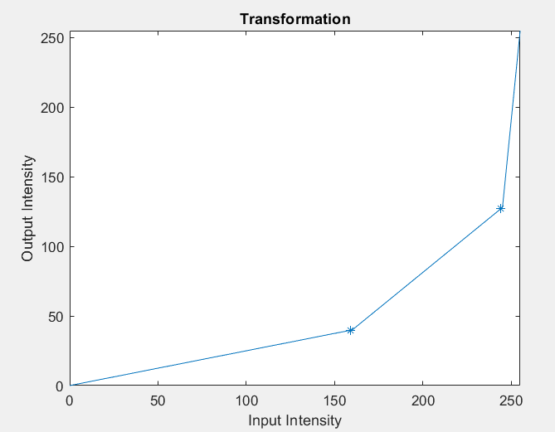

|  |  |  |  |  |  |  |  |
| --- | --- | --- | --- | --- | --- | --- | --- |
| Correlation | | | | | | | |
|  |  | Sigma | | | | | |
|  |  | 0 | 1 | 2 | 3 | 4 | 5 |
| Noise | 0 | 0.965792 | 0.969891 | 0.917495 | 0.873248 | 0.852239 | 0.839839 |
| 1 | 0.913549 | 0.955916 | 0.912018 | 0.871283 | 0.851057 | 0.839282 |
| 2 | 0.878104 | 0.945819 | 0.898524 | 0.868345 | 0.851431 | 0.839839 |
| 3 | 0.846237 | 0.937143 | 0.893791 | 0.862885 | 0.850053 | 0.840805 |
| 4 | 0.835504 | 0.93127 | 0.893636 | 0.863047 | 0.849373 | 0.839351 |
| 5 | 0.83463 | 0.923538 | 0.891087 | 0.862224 | 0.847441 | 0.840271 |
| 6 | 0.834473 | 0.916301 | 0.888987 | 0.860618 | 0.847275 | 0.837298 |
| 7 | 0.832688 | 0.917328 | 0.879976 | 0.860357 | 0.846619 | 0.837161 |
| 8 | 0.831505 | 0.911404 | 0.882923 | 0.859721 | 0.84524 | 0.838907 |
| 9 | 0.8338 | 0.902964 | 0.877366 | 0.85718 | 0.846113 | 0.836891 |
| 10 | 0.831968 | 0.911185 | 0.876956 | 0.857602 | 0.844551 | 0.835086 |

|  |  |  |  |  |  |  |  |
| --- | --- | --- | --- | --- | --- | --- | --- |
| X Distance from Correct Location | | | | | | | |
|  |  | Sigma | | | | | |
|  |  | 0 | 1 | 2 | 3 | 4 | 5 |
| Noise | 0 | 0 | 0 | 0 | 0 | 46 | 45 |
| 1 | 62 | 62 | 0 | 0 | 46 | 45 |
| 2 | 2 | 62 | 0 | 0 | 46 | 45 |
| 3 | 62 | 0 | 2 | 46 | 45 | 45 |
| 4 | 174 | 62 | 62 | 24 | 45 | 45 |
| 5 | 174 | 62 | 62 | 1157 | 24 | 25 |
| 6 | 174 | 62 | 2 | 45 | 45 | 45 |
| 7 | 174 | 62 | 62 | 1157 | 46 | 45 |
| 8 | 391 | 62 | 62 | 1157 | 1157 | 45 |
| 9 | 174 | 62 | 62 | 1157 | 45 | 45 |
| 10 | 888 | 62 | 24 | 24 | 1157 | 45 |

|  |  |  |  |  |  |  |  |
| --- | --- | --- | --- | --- | --- | --- | --- |
| Y Distance from Correct Location | | | | | | | |
|  |  | Sigma | | | | | |
|  |  | 0 | 1 | 2 | 3 | 4 | 5 |
| Noise | 0 | 0 | 0 | 0 | 0 | 105 | 106 |
| 1 | 82 | 82 | 0 | 0 | 105 | 106 |
| 2 | 67 | 82 | 0 | 0 | 106 | 106 |
| 3 | 82 | 0 | 66 | 105 | 105 | 106 |
| 4 | 177 | 82 | 82 | 924 | 105 | 106 |
| 5 | 176 | 82 | 82 | 396 | 864 | 864 |
| 6 | 177 | 82 | 67 | 105 | 105 | 105 |
| 7 | 177 | 82 | 82 | 396 | 105 | 105 |
| 8 | 228 | 82 | 82 | 396 | 396 | 106 |
| 9 | 176 | 82 | 82 | 396 | 105 | 106 |
| 10 | 476 | 82 | 864 | 864 | 396 | 106 |

At low levels of noise, adding a smoothing of sigma 2 or greater seems to decrease the maximum possible correlation between the template and the image. This is due to the fact that, assuming that the template itself comes directly from the image and contains little noise, an image with only few alterations to it still has the potential to fit the template almost perfectly, and altering the image at this point may differentiate it from template even further and decrease correlation. However, higher levels of noise have a chance to obscure the image and distract the template from matching up correctly in the image. This is why with the addition of noise, the max correlation from a 0 sigma smoothing (no smoothing at all) starts to drop off significantly with every additional level of noise. In this case, smoothing the image, and changing each pixel to be a select accumulation of its surrounding pixels may decrease the effect of each individual bit of noise overall. This effect can be seen in the significant increase in correlation when a smoothing of sigma 1 or more is used with an image with added noise. From the results, it seems that a smoothing of sigma 1 is the optimal value to use in terms of maximizing correlation for the examined data. However, it can also be noted that a high correlation does not always indicate the optimal sigma for smoothing in regard to matching the template to the correct location. When viewing the error in location caused by each combination, sigma values of 2 and 3 will result in more correct matches for noise levels of 1 and 2, than a sigma of 1 would, despite having lower correlations. This may be possible due to the fact that, though noise can lower correlation, it also has the capacity contain a similar enough orientation to the template, and trick a program into calculating a larger correlation than is deserved. Overall, gaussian filters can be used to limit the high changes in intensity that usually comes with noise, while mostly preserving low changes of intensities in the original image. This comes at the cost of significantly altering the high changes in intensity in the original image as well, and can have the potential to hurt the effectiveness of an template matching program if not used in moderation.

Code Used

# CompVisHw2_1.py - Compares effectiveness of template matching with different levels of blur and noise

# Created on 10/20/19

# @author: Richard Ngo

import numpy as np, cv2

################################

#noisy - modified from Shubham Pachori on stackoverflow

def noisy(image, noise_type, sigma):

if noise_type == "gauss":

row,col = image.shape

mean = 0

gauss = np.random.normal(mean,sigma,(row,col))

gauss = gauss.reshape(row,col)

noisy = image + gauss

return noisy

elif noise_type == "s&p":

row,col = image.shape

s_vs_p = 0.5

amount = 0.004

out = np.copy(image)

# Salt mode

num_salt = np.ceil(amount * image.size * s_vs_p)

coords = [np.random.randint(0, i - 1, int(num_salt))

for i in image.shape]

out[coords] = 1

# Pepper mode

num_pepper = np.ceil(amount* image.size * (1. - s_vs_p))

coords = [np.random.randint(0, i - 1, int(num_pepper))

for i in image.shape]

out[coords] = 0

return out

elif noise_type == "poisson":

vals = len(np.unique(image))

vals = 2 ** np.ceil(np.log2(vals))

noisy = np.random.poisson(image * vals) / float(vals)

return noisy

elif noise_type =="speckle":

row,col = image.shape

gauss = np.random.randn(row,col)

gauss = gauss.reshape(row,col)

noisy = image + image * gauss

return noisy

################################

img = cv2.imread('motherboard-gray.png', cv2.IMREAD_GRAYSCALE)

temp = cv2.imread('template.png', cv2.IMREAD_GRAYSCALE)

heightI = len(img)

widthI = len(img[0])

heightT = len(temp)

widthT = len(temp[0])

maxnoise = 10

maxsig = 5

maxcorr = np.zeros((maxnoise+1, maxsig+1), dtype = "float32")

maxlocy = np.zeros((maxnoise+1, maxsig+1), dtype = "int64")

maxlocx = np.zeros((maxnoise+1, maxsig+1), dtype = "int64")

for N in range(maxnoise+1):

for S in range(maxsig+1):

no = np.uint8(noisy(img, 'gauss', N))

if S == 0:

nosm = no

else:

nosm = cv2.GaussianBlur(no,(S*6+1,S*6+1), S)

matched = cv2.matchTemplate(nosm,temp,cv2.TM_CCORR_NORMED)

max_val = np.amax(matched)

loc = np.where(matched==max_val)

#for viewing

maxcorr[N,S] = max_val

maxlocy[N,S] = abs(loc[0][0]-382)

maxlocx[N,S] = abs(loc[1][0]-438)

N = maxnoise

S = maxsig

heightM = len(matched)

widthM = len(matched[0])

dst = np.zeros(shape=(len(matched),len(matched[0])))

matched = np.uint8(cv2.normalize(matched,dst,0,255,cv2.NORM_MINMAX))

histEqmatched = cv2.equalizeHist(matched)

transmatch = np.zeros((heightM, widthM), dtype = "uint8")

#Piecewise-Linear Transformation

r1 = 160#input

s1 = 40#output

r2 = 245#input

s2 = 128#output

for i in range(heightM):

for j in range(widthM):

if matched[i,j] <= r1:

transmatch[i,j] = s1/r1*matched[i,j]#if intensity of image is below or equal to r1

elif matched[i,j] >= r2:

transmatch[i,j] = (255-s2)/(255-r2)*(matched[i,j]-r2)+s2#if intensity of image is above or equal to r2

else:

transmatch[i,j] = (s2-s1)/(r2-r1)*(matched[i,j]-r1)+s1#if intensity of image is between r1 and r2

heightI = len(nosm)

widthI = len(nosm[0])

#show resulting images for N = 10, S = 5

cv2.namedWindow('Noise: N='+str(N)+' S='+str(S), flags=cv2.WINDOW_NORMAL)

cv2.imshow('Noise: N='+str(N)+' S='+str(S), no)

cv2.resizeWindow('Noise: N='+str(N)+' S='+str(S), (int(widthI/2), int(heightI/2)))

cv2.namedWindow('Smoothed: N='+str(N)+' S='+str(S), flags=cv2.WINDOW_NORMAL)

cv2.imshow('Smoothed: N='+str(N)+' S='+str(S), nosm)

cv2.resizeWindow('Smoothed: N='+str(N)+' S='+str(S), (int(widthI/2), int(heightI/2)))

cv2.namedWindow('Corr: N='+str(N)+' S='+str(S), flags=cv2.WINDOW_NORMAL)

cv2.imshow('Corr: N='+str(N)+' S='+str(S), matched)

cv2.resizeWindow('Corr: N='+str(N)+' S='+str(S), (int(widthM/2), int(heightM/2)))

cv2.namedWindow('HECorr: N='+str(N)+' S='+str(S), flags=cv2.WINDOW_NORMAL)

cv2.imshow('HECorr: N='+str(N)+' S='+str(S), histEqmatched)

cv2.resizeWindow('HECorr: N='+str(N)+' S='+str(S), (int(widthM/2), int(heightM/2)))

cv2.namedWindow('LTCorr: N='+str(N)+' S='+str(S), flags=cv2.WINDOW_NORMAL)

cv2.imshow('LTCorr: N='+str(N)+' S='+str(S), transmatch)

cv2.resizeWindow('LTCorr: N='+str(N)+' S='+str(S), (int(widthM/2), int(heightM/2)))

cv2.waitKey(0)

cv2.destroyAllWindows()

Part 2

Original Image

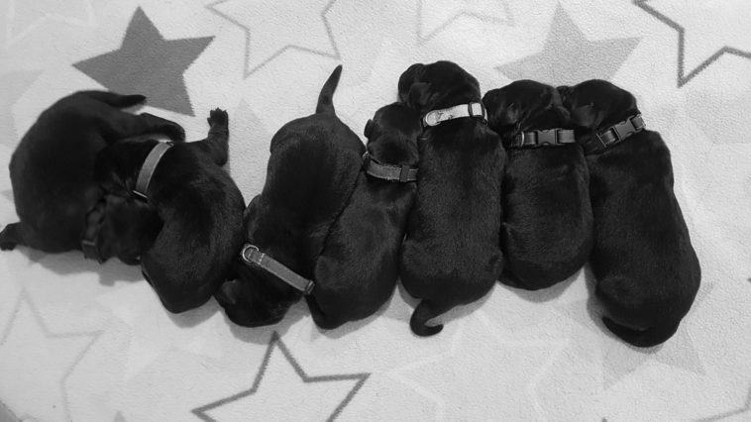

Distance Image

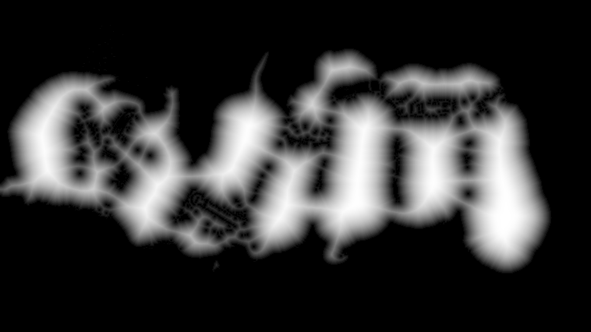

Segmentated Image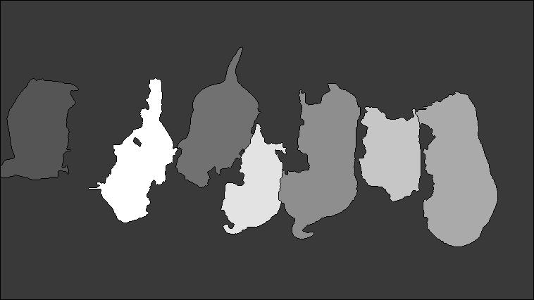 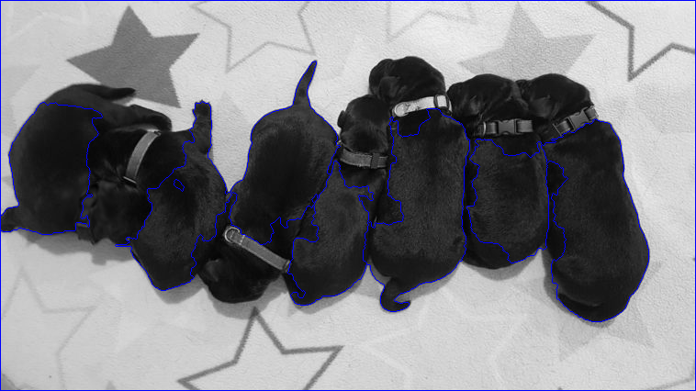

Code Used

# CompVisHw2_2.py - Setting up puppies for watershed seperation

# Created on 10/21/19

# @author: Richard Ngo

import cv2

import numpy as np

img = cv2.imread('puppies.png',0)

#set bright boundaries to backround

ret,backround = cv2.threshold(img,105,255,cv2.THRESH_TOZERO_INV)#70, 105

#set dark boundaries between dogs to backround

ret,backround = cv2.threshold(backround,9,255,cv2.THRESH_BINARY)#9, 10

#cv2.imshow('backround', backround)

distIm = cv2.distanceTransform(backround,cv2.DIST_L2,5)

dst = np.zeros(shape=(len(distIm),len(distIm[0])))

#cv2.imshow('distanceT', np.uint8(cv2.normalize(distIm,dst,0,255,cv2.NORM_MINMAX)))

cv2.imshow('distance transform', cv2.equalizeHist(np.uint8(cv2.normalize(distIm,dst,0,255,cv2.NORM_MINMAX))))

ret, foreground = cv2.threshold(distIm,0.55*distIm.max(),255,0)

#cv2.imshow('foreground', foreground)

foreground = np.uint8(foreground)

backround = np.uint8(backround)

#code based on opencv watershed tutorial from here on out

#https://docs.opencv.org/master/d3/db4/tutorial_py_watershed.html

#to be flooded

unknown = cv2.subtract(backround,foreground)

#cv2.imshow('unknown', unknown)

#markers

ret, markers = cv2.connectedComponents(foreground)

# make backround the shallowest segment

markers = markers+1

# set up region to be flooded

markers[unknown==255] = 0

#cv2.imshow('markers', np.uint8(np.uint8(cv2.normalize(markers,dst,0,255,cv2.NORM_MINMAX))))

img = cv2.imread('puppies.png')

cv2.imshow('Original Image', img)

#blur image for more effective segmentation

imgGB = cv2.GaussianBlur(img,(5,5),5)#9,9,1 5,5,5 11,11,3 11,11,1

markers = cv2.watershed(imgGB,markers)

"""

#layered watershed?

test = markers

unknownT = unknown

unknownT[test > 1] = 0

test[unknownT==255] = 0

test[test == -1] = 0

#test[unknown==255] = 0

#test[unknown<255] = 1

#unknownT = unknown

#test[markers == -1] = 0

#test[markers <= 1] = 0

#unknownT[test == 255] = 0

#test[unknownT==255] = 0

#ret, test = cv2.connectedComponents(test)

#test = cv2.watershed(imgGB,test)

#test = np.uint8(cv2.normalize(test,dst,0,255,cv2.NORM_MINMAX))

test = cv2.watershed(imgGB,test)

test = np.uint8(cv2.normalize(test,dst,0,255,cv2.NORM_MINMAX))

cv2.imshow('test', test)

"""

img[markers == -1] = [255,0,0]

cv2.imshow('Final Segmentations', np.uint8(cv2.normalize(markers,dst,0,255,cv2.NORM_MINMAX)))

cv2.imshow('Final Segmented Image', img)

print('number of segments found excluding backround',np.amax(markers)-1)

cv2.waitKey(0)

cv2.destroyAllWindows()